## 6.2 Discussion and Result of Main Experiment

Based on the preliminary experiment, we have already observed the advantages of including randomness in the charging pattern. Therefore, we run the second experiment mainly based on the scheme where all the alternative plans are with randomness, i.e. charging plan 1, 3 and 5.

And the main goal of this part is to look deeper into how the charging plans, flexibility of households, and optimization goal, affect the grid robustness and cost. The detailed discussion of each factor are discussed in the following section.

### 6.2.1 Effect of charging plans on robustness

To compare the effectiveness of random charging plan 1, 3, and 5 on improving the grid robustness, we run the experiments in different schemes while keep other variables unchanged. And the neighborhood are set to have highest flexibility, i.e. all EV’s have alternative plans.

Table 6.2 Patterns of schemes for evaluating the effect of charging plans

|  |  |  |  |  |  |  |
| --- | --- | --- | --- | --- | --- | --- |
| Experiment Reference Name | Number of Total EV | Number of EV with alternative plans | **Scheme for Alternative plans** | Car | State | Optimization goal |
| Benchmark | 1000 | 0 | [0] | Tesla | TEXAS | N/A |
| 151207_1k_1k_0111 | 1000 | 1000 | [0,1,1,1] | Tesla | TEXAS | robustness |
| 151207_1k_1k_0333 | 1000 | 1000 | [0,3,3,3] | Tesla | TEXAS | robustness |
| 151207_1k_1k_0555 | 1000 | 1000 | [0,5,5,5] | Tesla | TEXAS | robustness |
| 151207_1k_1k_0135 | 1000 | 1000 | [0,1,3,5] | Tesla | TEXAS | robustness |

As the robustness is defined as the total electricity consumption. Therefore, the lower the volatility of the curve, the higher the robustness.

1. All four schemes with alternative plans can significantly reach a more stable electricity consumption along the whole day.

And the best scheme ([0,1,1,1]) with standard deviation 160.95 can improve the benchmark situation 450.02 by 64.2%. It is because by adopting random charging plans (plan 1, 3 or 5), the households can flexibly coordinate with other candidate by shifting individual load demand to non-busy hours, which contributes to the robustness of the grid.

1. The charging steps in random charging plans do not make significance differences on the robustness of the grid.

The standard deviation of schemes with alternative plans are in the range of 160 to 188, where scheme [0,1,1,1] has the best performance. One possible reason is that scheme [0,1,1,1] uses 1 step charging with one random starting point, it will be easier to locally coordinate different households by separating their initial starting points.



Table 2 Power consumption using different schemes with alternative plan 1, 3, 5

### 6.2.2 Effect of flexible households on the robustness

Table 6.3 Patterns of schemes for evaluating the effect of flexible households on the robustness

|  |  |  |  |  |  |  |
| --- | --- | --- | --- | --- | --- | --- |
| Experiment Reference Name | Number of Total EV | **Number of EV with alternative plans** | Scheme for Alternative plans | Car | State | Optimization goal |
| Benchmark | 1000 | 0 | [0] | Tesla | TEXAS | N/A |
| 151207_1k_200_0135 | 1000 | 200 | [0,1,3,5] | Tesla | TEXAS | robustness |
| 151207_1k_400_0135 | 1000 | 400 | [0,1,3,5] | Tesla | TEXAS | robustness |
| 151207_1k_600_0135 | 1000 | 600 | [0,1,3,5] | Tesla | TEXAS | robustness |
| 151207_1k_800_0135 | 1000 | 800 | [0,1,3,5] | Tesla | TEXAS | robustness |
| 151207_1k_1k_0135 | 1000 | 1000 | [0,1,3,5] | Tesla | TEXAS | robustness |

By changing the flexible household percentage, i.e. number of EV’s with alternative plans in a fixed community, we try to discover how and how much the number of flexible households can improve the robustness of the grid. By using the same household data as 6.2.1, with fixed alternative plan scheme [0,1,3,5], we linearly increase the number of flexible household to investigate the improvement of robustness (standard deviation).

1. Increase of the flexible household percentage can improve the robustness of grid.

As percentage of flexible households increase from 0% (benchmark) to 100% (full collaboration), the positive effect on load shifting are always observed. Especially, it is obvious in the graph that the peak load value around 18:00 decreases, and the average midnight consumption increases, when increasing the flexible household percentage.

1. The grid robustness, measure in standard deviation, has negative near-linear relationship with the percentage of flexible households.

The graph 6.4, shows good linearity between these two variables. It can be inferred that, people can have a linear expectation of grid robustness improvement when increase the cooperation level of micro grid. Every marginal individual who joins the micro grid, can have a similar contribution to the robustness.

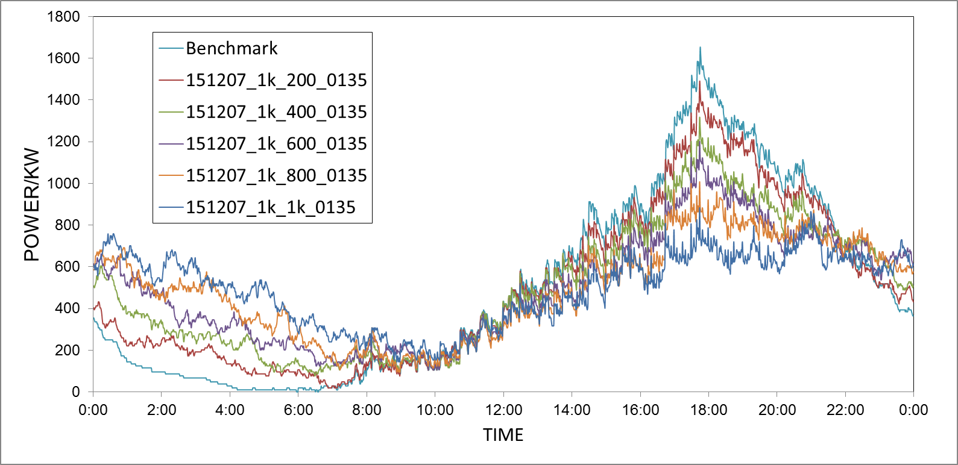

Figure 6.3 Power consumption with variable numbers of flexible households

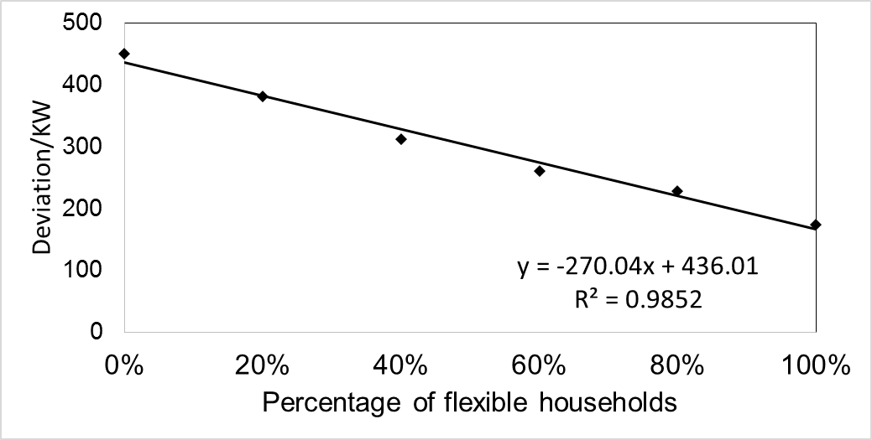

Figure 6.4 The relationship between deviation and percentage of flexible households

### 6.2.3 Effect of household flexibility on the cost

Table 6.4 Patterns of schemes for evaluating the effect of flexible households on the cost

|  |  |  |  |  |  |  |
| --- | --- | --- | --- | --- | --- | --- |
| Experiment Reference Name | Number of Total EV | **Number of EV with alternative plans** | Scheme for Alternative plans | Car | State | **Optimization goal** |
| 151207_1k_200_0135 | 1000 | 200 | [0,1,3,5] | Tesla | TEXAS | cost minimization |
| 151207_1k_400_0135 | 1000 | 400 | [0,1,3,5] | Tesla | TEXAS | cost minimization |
| 151207_1k_600_0135 | 1000 | 600 | [0,1,3,5] | Tesla | TEXAS | cost minimization |
| 151207_1k_800_0135 | 1000 | 800 | [0,1,3,5] | Tesla | TEXAS | cost minimization |
| 151207_1k_1k_0135 | 1000 | 1000 | [0,1,3,5] | Tesla | TEXAS | cost minimization |

As is shown in Table 6.4, the scheme whose pattern is [0,1,3,5] is applied for the simulation to optimize cost. The number of households that are capable of performing optimization is varying to study the effect of household flexibility on the cost.

**Cost decreases as optimization is performed.** As is shown in Table 6. , the cost dropped from totally 1494.42 USD to 1022.35 USD when every households in the grid is involved in cost optimization. The aptitude of 32.6% cost saving validated the effectiveness of our alternative plans on cost optimization. When less the household flexibility is given, *i.e.,* number of household that is able to do cost performance decreases, the effect of cost saving become less significant as is expected. The effect of the optimization goal can be explained as: household with capability of selecting different schemes can choose the optimal one corresponding to the cost signal so that is able to distribute their power consumption to the off-peak hours. This is demonstrated by Figure 6., where shows that significant increases of power consumption exist exactly at the starting of off-peak hours and the aptitude of increase is corresponding to the household flexibility.

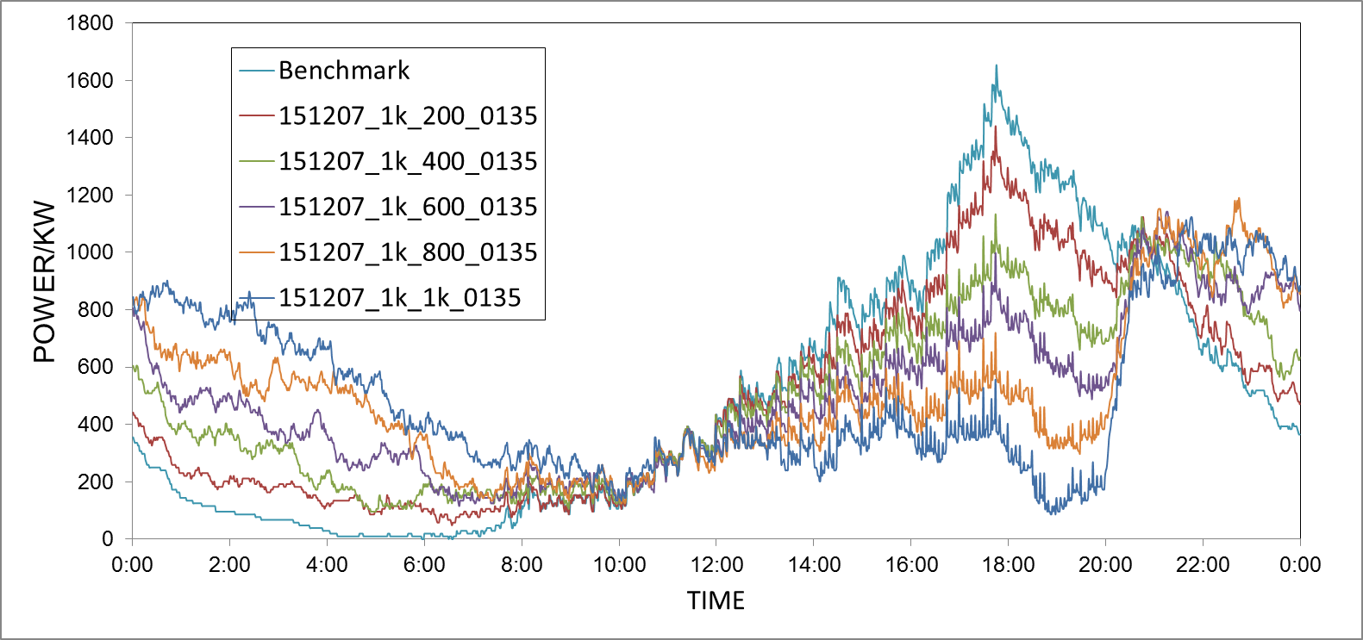

Figure 6.5 Power consumption after cost optimization with variable number of flexible households

Table 6.5 Result of cost optimization

|  |  |  |  |  |  |  |
| --- | --- | --- | --- | --- | --- | --- |
| Percentage of flexible households | Original | 20% | 40% | 60% | 80% | 100% |
| Average/KW | 496.04 | 495.92 | 495.80 | 495.64 | 495.60 | 495.56 |
| Deviation/KW | 450.02 | 366.04 | 295.90 | 255.98 | 259.32 | 277.15 |
| Cost/USD | 1494.42 | 1406.21 | 1301.65 | 1215.60 | 1112.46 | 1022.35 |

Influence of cost optimization on robustness of the grid. Although only cost is set as an optimization goal in this experiment, we can expect there would still be an influence on the grid’s robustness because the power consumption curves are altered as is shown in Figure 6.5. By comparing the deviations of different curves in Table 6.5, we can see the deviations initially drop as the household flexibility increase while grow up after a certain point. This can be understood as: cost optimization makes household to redistribute their power consumption from originally being around 17h00 to being at 20h00 which is the starting of off-peak hours and evenness of such a redistribution which results in the change of the deviations is mainly effected by the household flexible. If the number of households that redistribute their power consumption is comparable with the number of households that do not, the peak at the original peak time would be balanced with the emerging peak, leading to a positive effect on grid robustness. It is also noticeable that the deviations using cost optimization with 400-, 600- and 800- household flexibility are smaller than those using robustness optimization. This reveals that it is incompletely appropriate to evaluate the robustness of grid only with the minimum deviations.